Name: L.KESAVA
Reg No:192524184
1)Suppose a modern Operating System supports multiple users and processes
with shared resources like CPU, memory, and I/O devices.
(a) Classify different types of Operating Systems suitable for this scenario and
justify your choice.
(b) Draw the structure of an Operating System showing how resources are
managed.
(c) Write a sequence of system calls required to create and execute a new
process in such an environment.

(a) Types of Operating Systems
- Multiuser OS: Allows multiple users to access the system simultaneously. Example: UNIX, Linux.
- Multiprocessing OS: Uses multiple CPUs or cores to execute processes efficiently.
- Time-sharing OS: Shares CPU time among multiple users and processes.
- Multitasking OS: Runs multiple applications concurrently.
Justification: A combination of multiuser, multiprocessing, and time-sharing OS is suitable because it manages shared CPU, memory, and I/O devices efficiently.

b) OS structure diagram

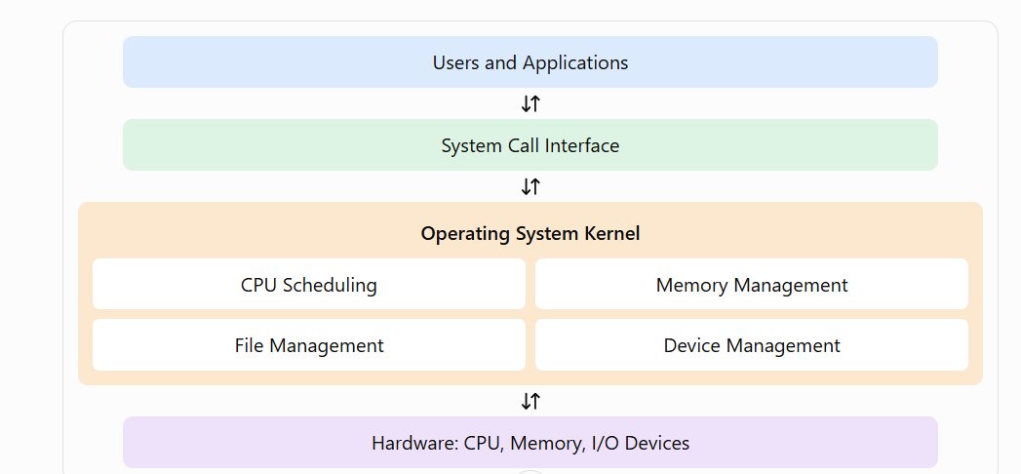

(c) System calls to create a process
Sequence in UNIX/Linux:
pid = fork();
if (pid == 0)
execl("/bin/ls", "ls", NULL);
else
wait(NULL);
- fork() – Creates a new process.
- execl() – Executes a new program in the child process.
- wait() – Waits for the child process to finish.

2) File and Device Management

(a) Categories of system calls
- File management: open(), read(), write(), close(), unlink().
- Device management: ioctl(), open(), read(), write(), close().
- File information: stat(), fstat().
- Device control: Configure devices, read status, and control device operations.

(b) Layered structure diagram
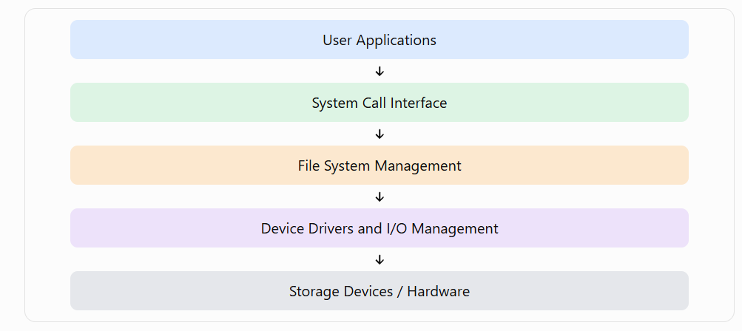

Explanation: The file system processes file requests, while device drivers communicate with hardware to perform read and write operations.
(c) C program to open, read, and close a file

#include <fcntl.h>
#include <unistd.h>

int main() {
char b[100];
int f = open("data.txt", O_RDONLY);
if (f < 0) return 1;
read(f, b, 99);
close(f);
return 0;
}
- open() – Opens the file.
- read() – Reads file contents.
- close() – Closes the file descriptor.

3) Real-Time Operating System (RTOS)

(a) Type and suitability
A Real-Time Operating System (RTOS) is suitable for embedded industrial machinery.
Types:
- Hard RTOS: Deadlines must never be missed in critical operations.
- Soft RTOS: Occasional deadline misses are acceptable.
Advantages:
- Provides predictable response times.
- Supports priority-based scheduling.
- Enables fast interrupt handling.
- Improves reliability and synchronization.

b) Hardware, kernel, and user processes
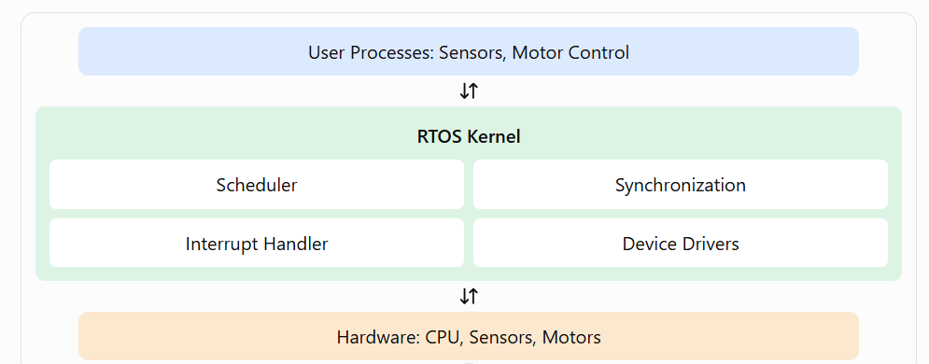

(c) System calls for process synchronization
- Semaphore operations: sem_wait() and sem_post() control access to shared resources.
- Mutex operations: pthread_mutex_lock() and pthread_mutex_unlock() protect critical sections.
- Condition variables: pthread_cond_wait() and pthread_cond_signal() coordinate processes or threads.
- Message queues: mq_send() and mq_receive() exchange messages between tasks.
These operations help prevent race conditions and coordinate task execution. Some are POSIX library calls rather than direct kernel system calls.

4) Distributed Operating System
(a) Classification and comparison
A Distributed Operating System manages multiple interconnected computers and coordinates their shared resources.
Distributed OS | Centralized OS
Uses multiple connected computers | Mainly managed by one central computer
Resources are distributed across nodes | Resources are mainly at the central system
Can provide better scalability | Expansion may depend on the central system
Network communication is required | Users primarily access the central system
Example: Amoeba is a distributed operating system; UNIX/Linux can be used in centralized systems.

(b) Distributed OS architecture
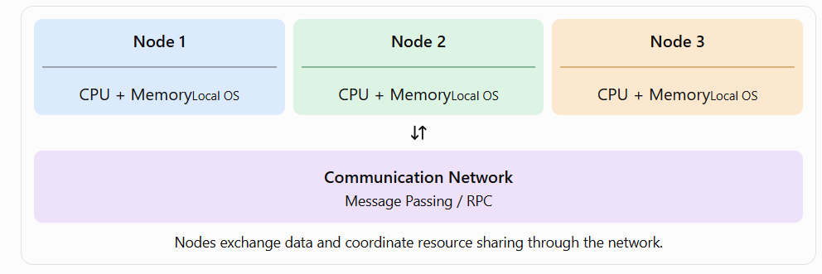

(c) System call sequence for IPC
Example using UNIX pipes:
pipe(fd);
pid = fork();

if (pid == 0) {
close(fd[0]);
write(fd[1], "Hello", 5);
close(fd[1]);
} else {
close(fd[1]);
read(fd[0], buf, 5);
close(fd[0]);
}
- pipe() – Creates a communication channel.
- fork() – Creates a child process.
- write() – Sends data.
- read() – Receives data.
- close() – Closes the file descriptors.
Note: Pipes work between related processes on the same system. Distributed nodes generally use sockets or RPC for network communication.

5) Major Functions of an Operating System

(a) Explain the major functions
- Process management: Creates, schedules, and terminates processes; allocates CPU time.
- Memory management: Allocates and frees memory and manages virtual memory.
- Device management: Controls I/O devices through device drivers.
- File management: Creates, reads, writes, and deletes files.
- Security and protection: Controls user access and protects resources.
- Resource allocation: Shares CPU, memory, and devices efficiently among processes.

(b) OS components and interactions

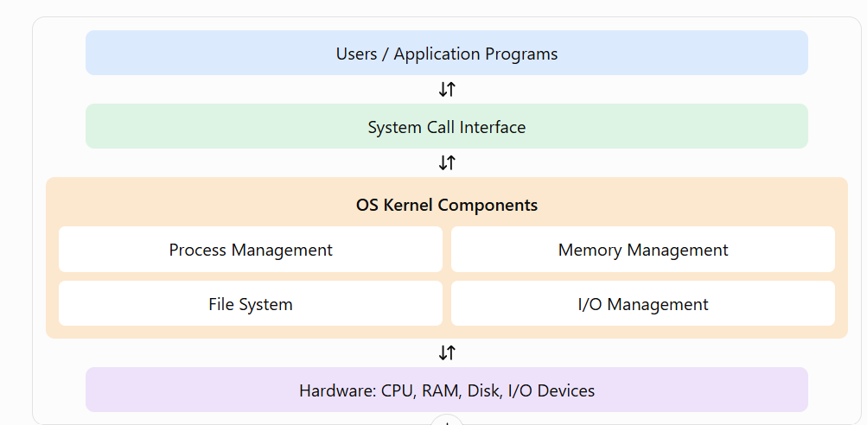
(c) System calls for memory and device management
Memory management examples (UNIX/Linux):
void *p = mmap(0, 4096, 3, 0x22, -1, 0);
munmap(p, 4096);
- mmap() – Maps memory into the process address space.
- munmap() – Removes the memory mapping.

Device management example:
int f = open("/dev/example", O_RDWR);
if (f >= 0) {
read(f, buf, 10);
close(f);
}
- open() – Opens a device.
- read() – Reads data from the device.
- close() – Releases the device file descriptor.

Note: Device paths and permissions depend on the operating system and installed hardware.

